Task 1: Create 3 EC2
Task 1: Create 3 EC2
2 Ubuntu instance and 1 AWS instance

Pre-requisists:
- Install python3 and ansible
  - sudo apt update
  - sudo apt install ansible -y
  - sudo apt install python3-pip -y
  - pip install boto3
  - ansible-galaxy collection install amazon.aws

Steps:

- Create vault to store access key
  - openssl rand -base64 2048 > vault.pass
  - ansible-vault create group_vars/all/pass.yaml --vault-password-file vault.pass
    - Enter the access and secret keys
      - 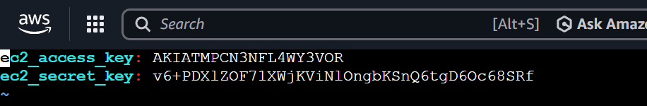

- Create yaml file for ansible playbook
---
- hosts: localhost
connection: local

tasks:
- name: Start EC2 instances
amazon.aws.ec2_instance:
name: "{{ item.name }}"
key_name: "UbuntuSSHKey"
instance_type: "t3.micro"
security_group: "default"
region: "ap-south-1"
aws_access_key: "{{ec2_access_key}}"
aws_secret_key: "{{ec2_secret_key}}"
image_id: "{{ item.image }}"
network_interfaces:
- assign_public_ip: true
state: present

loop:
- { image: "ami-0db56f446d44f2f09", name: "aws-instance" }
- { image: "ami-07a00cf47dbbc844c", name: "ubuntu-instance-1" }
- { image: "ami-07a00cf47dbbc844c", name: "ubuntu-instance-2" }

- To run:
  - ansible-playbook ec2_create.yaml --vault-password-file vault.pass

Output:

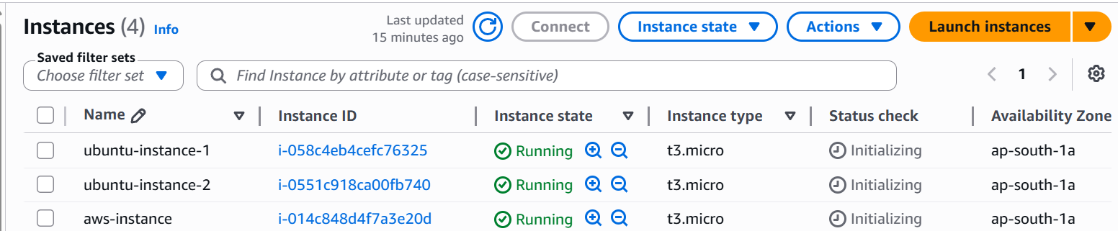

amazon.aws.ec2_instance module – Create & manage EC2 instances — Ansible Community Documentation

Task 2: Stop the instances created
Task 2: Stop the instances created

- Create ansible playbook file
---
- hosts: localhost
connection: local
gather_facts: false

tasks:
- name: Stop EC2 instances
amazon.aws.ec2_instance:
name: "{{ item }}"
region: "ap-south-1"
aws_access_key: "{{ ec2_access_key }}"
aws_secret_key: "{{ ec2_secret_key }}"
state: stopped
loop:
- aws-instance
- ubuntu-instance-1
- ubuntu-instance-2

- Run the command:
  - ansible-playbook ec2_stop.yaml --vault-password-file vault.pass

Output:
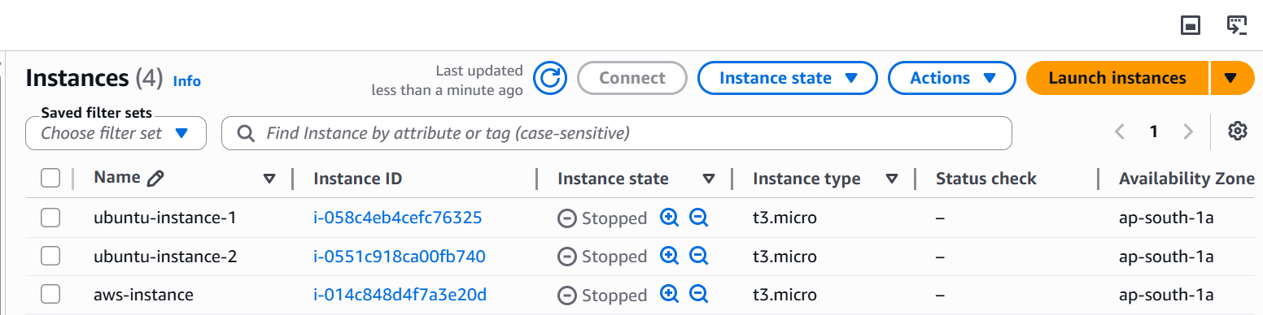

To Terminate:

state: absent

Output:
